A MINI PROJECT REPORT
On
HR Case Study

Submitted by

Name: Anujay Jain Name: Nihit Jain
Roll No: 161500106 Roll No: 161500350

Name: Utkarsh Rai Name: Shahaban Ali
Roll No: 161500599 Roll No:161500496

To
Mr. Rahul Pradhan

Department of Computer Engineering & Applications
Institute of Engineering & Technology



GLA University
Mathura- 281406, INDIA
December, 2018
Department of Computer Engineering and Applications
GLA University, Mathura
17 km. Stone NH#2, Mathura-Delhi Road, P.O. – Chaumuha,
Mathura – 281406

Declaration
We hereby declare that the work which is being presented in the Mini Project “Multiple Regression and Model Building”, in partial fulfillment of the requirements for Mini-Project LAB, is an authentic record of our own work carried under the supervision of Mr. Rahul Pradhan, Assistant Professor, GLA University, Mathura.

Anujay Jain
Sign:_________

Nihit Jain
Sign:_________

Utkarsh Rai
Sign:_________

Department of Computer Engineering and Applications
GLA University, Mathura
17 km. Stone NH#2, Mathura-Delhi Road, P.O. – Chaumuha,
Mathura – 281406

CERTIFICATE

This is to certify that the project entitled “HR Case Study” carried out in Mini Project – I Lab is a bonafide work done by Anujay Jain (161500106), Nihit Jain (161500350), Shahaban Ali(161500599) and Utkarsh Rai (161500599)and is submitted in partial fulfillment of the requirements for the award of the degree Bachelor of Technology (Computer Science & Engineering).

Signature of Supervisor:

Name of Supervisor:

Date:

ACKNOWLEDGEMENT

It gives us a great sense of pleasure to present the report of the B. Tech Mini Project undertaken during B. Tech. Third Year. This project in itself is an acknowledgement to the inspiration, drive and technical assistance contributed to it by many individuals. This project would never have seen the light of the day without the help and guidance that we have received.

Our heartiest thanks to Dr. (Prof). Anand Singh Jalal, Head of Dept., Department of CEA for providing us with an encouraging platform to develop this project, which thus helped us in shaping our abilities towards a constructive goal.

We owe special debt of gratitude to Mr. Rahul Pradhan, Assistant Professor Department of CEA, for his constant support and guidance throughout the course of our work. His sincerity, thoroughness and perseverance have been a constant source of inspiration for us. He has showered us with all his extensively experienced ideas and insightful comments at virtually all stages of the project & has also taught us about the latest industry-oriented technologies.

We also do not like to miss the opportunity to acknowledge the contribution of all faculty members of the department for their kind guidance and cooperation during the development of our project. Last but not the least, we acknowledge our friends for their contribution in the completion of the project.

Anujay Jain
Nihit Jain
Utkarsh Rai
Shahaban Ali

Abstract
In this problem, we have been provided with the information about various internships posted on Internshala. This includes various attributes about the internships like location, duration, start_date of internship etc. We have also been provided with information about the students who have applied for the internship. These include type_of_institute, current_year, academic performance of the student etc. Any student is free to apply for any internship on the portal.

While employers get high response to their posting, it is difficult to go through a high number of applications for the employers. They might need to go through high number of applications to shortlist the most relevant candidates. Hence an intelligent matching algorithm can help our users get better experience and enhance chances of meaningful profile matches.

Table of Contents
Declaration ii
Certificate iii
Acknowledgments iv
Abstract v

Table of Contents vi

- Chapter 1 1
1.1 Business Understanding….……………………...................................................1
1.2 Motivation .…………………………………………………...............................1
1.3 Scope…………………………………………………………………………….1
1.4 Drawbacks in existing system…………………………………………………...1

- Chapter 2 2
2.1 General Description…………………………………………………… ………..2
2.2 Project plan.……….……………..….………………………………………...…2
2.2.1 Objective…………………………………………………………………...2
2.2.2 Goal………………………………………………………………………...2
3. Chapter 3 3
3.1 Project Implementation……………………………………………………………3
3.2 Understanding the dataset………………………………………………………….3

- Chapter 7
3.1 Use Case ……………………….………………………………………………7-8
3.2 Data Flow Diagrams………………………………………………………………9-12
3.3 Logical Database Requirements…………………………………………………13

- Testing 14
  - Introduction………….……………………………………………………………. 14
  - Content Review……………………………………………………………………14
  - Navigation Errors………………………………………………………………….14
  - White- Box Testing………………………………………………………………..14
  - Black Box Testing…………………………………………………………………15
- Implementation and User Interface 16
  - FRAS Screens …………………………….........................................................16-22
6. References/Bibliography 23
Appendices 24-37

CHAPTER 1

1.1 Business Understanding
While employers get high response to their posting, it is difficult to go through a high number of applications for the employers. They might need to go through high number of applications to shortlist the most relevant candidates. Hence an intelligent matching algorithm can help our users get better experience and enhance chances of meaningful profile matches.

1.2 Motivation
The main motivation for us to go for this project was that a lot of internships are provided on internshala and a lot of applications for these internship are there, now if it the selection of the application is done manually it will consume lots of time and man-power and there are chances of human error. It is not possible to reduce the error of selection completely but if we can design a programme to select the most suitable candidate for a given internship then we ca reduce the time consumed and the workload and as it is being done by a machine the chances of error will also will be reduced and that is our goal.

1.3 Scope

The scope of our analysis is that we can reduce the workload for the company while selecting the most suitable interns for them among all the applicants. This is so, as based on our analysis we can find out those attributes which are most significant for the selection of the applicants thus helping us to focus on only those attributes rather than wasting our effort and time on other unrelated areas. Thus it will help as follows:
- Reduce the workload.
- Reduce the time consumed while selecting the suitable candidates.
- It can also be used by the applicants to know which are the more suitable internship for them.

1.4 Drawbacks in existing system

  - These days the selection for the internship is done manually which consumes more time.

  - These days the number of domains for which you can apply is increasing and the criteria for applying for an intern as well as the specification which the applicants are searching for has increased a lot thus increasing the chance of error while selecting the most suitable applicants.

CHAPTER 2

  - General Description
- Data collected from Internshala.
- A data is recorded in a file - Internship.csv, Student.csv and train.csv
2.2 Project Plan
2.2.1 Objective
- Build the best multiple regression model that can predict the most suitable candidate for the various internship present on the internshala, using all the other variables as the predictors.
- Determine which variables must be made into indicator variables.
- Determine which variables might be superfluous.

2.2.2 Goals
- To reduce the total number of applicants a company has to go over during the selection for the internship.
- To reduce the chances of error of selection a less suitable applicant when a more suitable one is present.

CHAPTER 3
3.1 Project Implementation
It includes the steps taken to implement the project.

  - Understanding the Dataset

- Student.csv
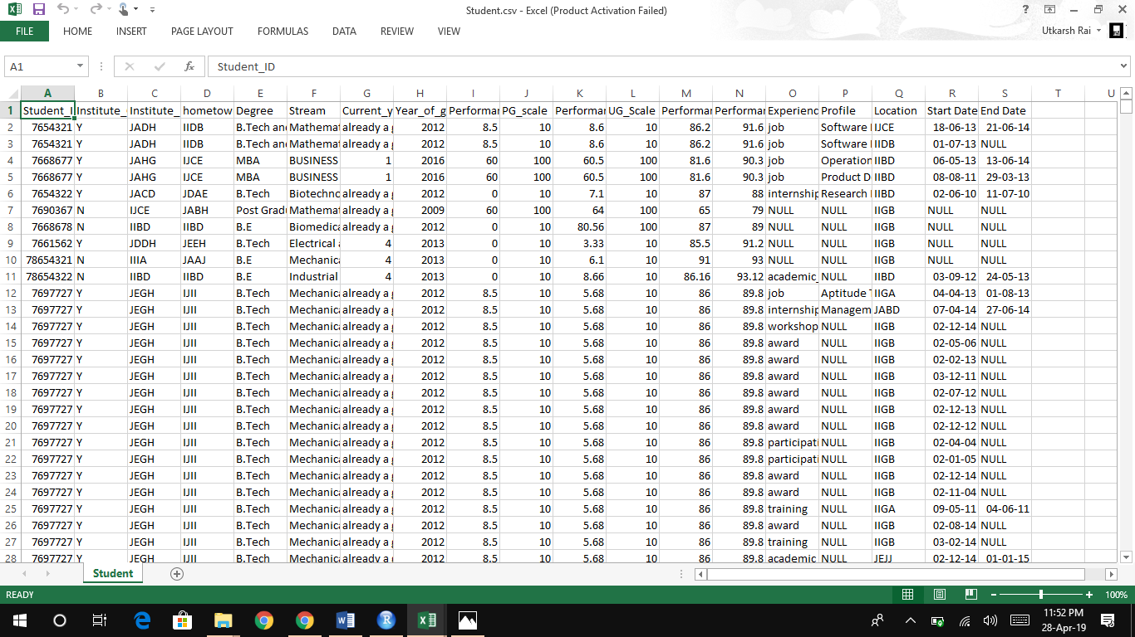

- Internship.csv

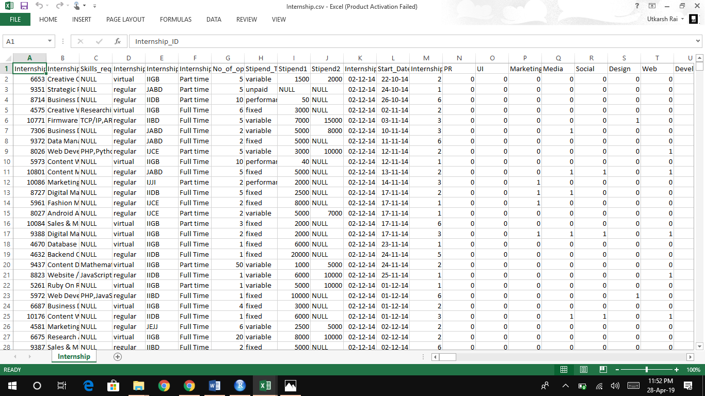

- train.csv
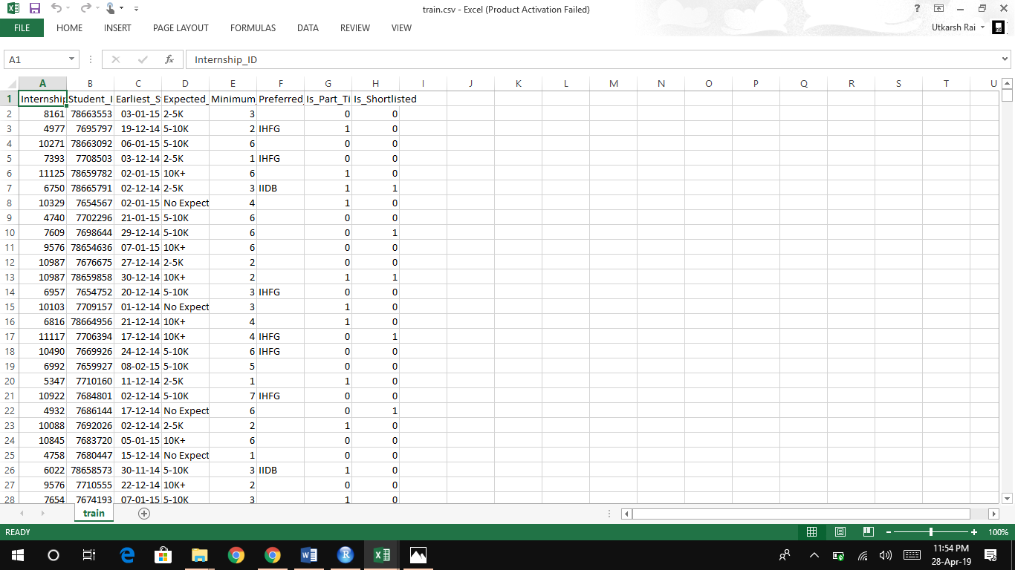

3.2 Describe data
The description of the column is as follows:

- Student.csv → It has 19 columns and 151191 rows.

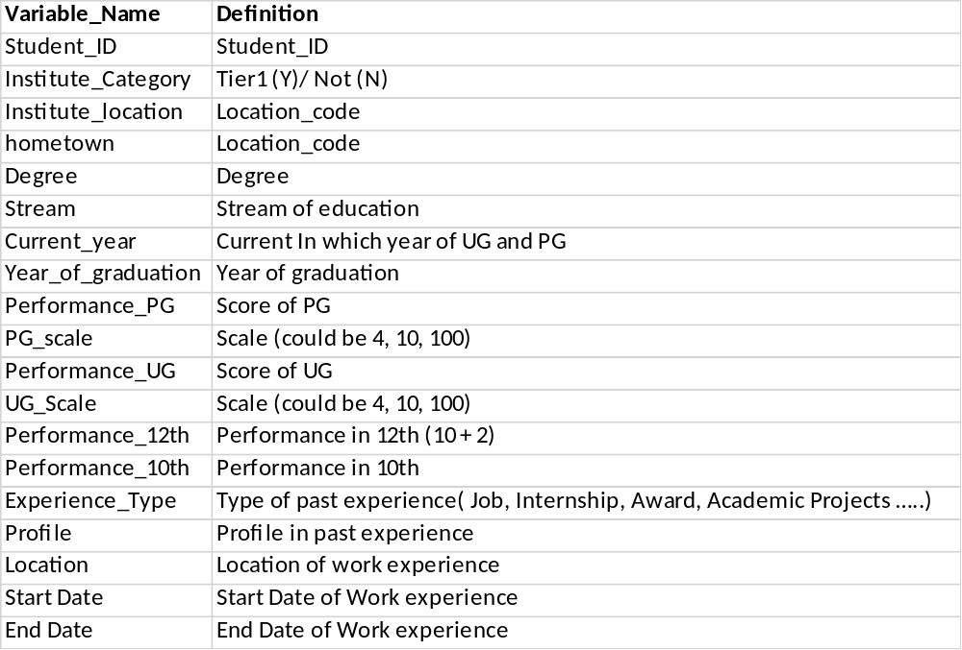

- Internship.csv → It has 286 columns and 6899 rows.

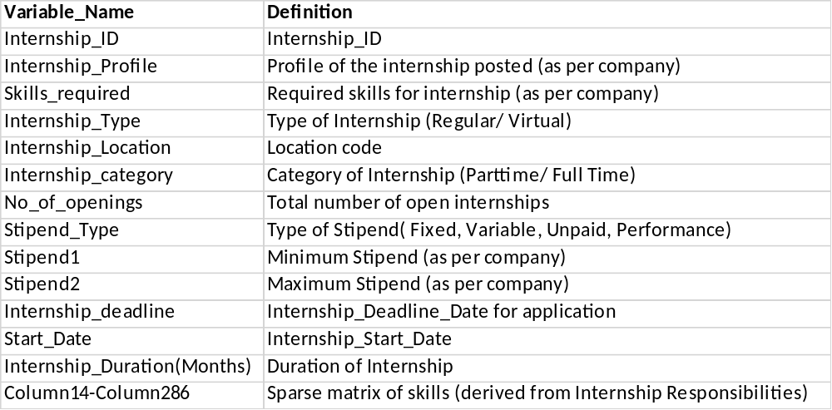

- train.csv → It has 8 columns and 192582 rows.

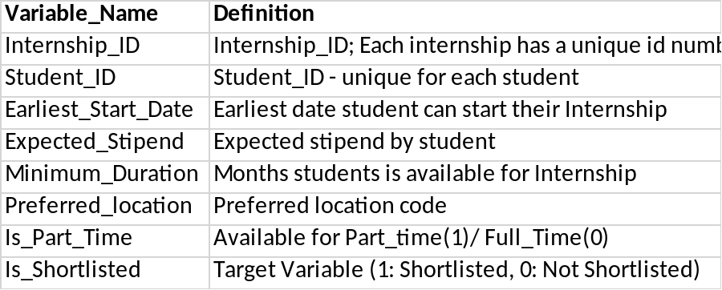

3.3 Data cleaning
The data which is obtained may need to be processed before it can be actually used, like there may be some values missing which need to be filled otherwise they will cause problem when doing the analyses on the data.

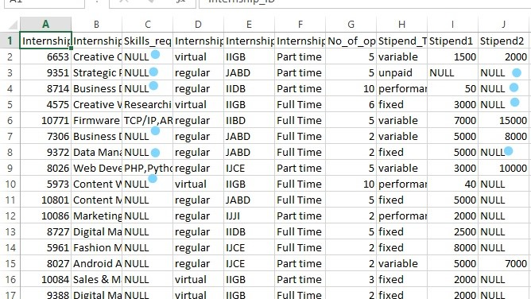

In the above image we can see that there are some null values so we need to fill them before we do anything else.

3.4 Data Insights

Here are certain insights of the data which may help in analyses:
- First five rows of the dataset
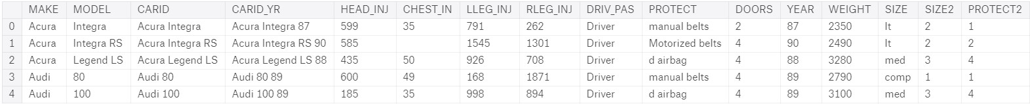

- Summary of the dataset after preprocessing
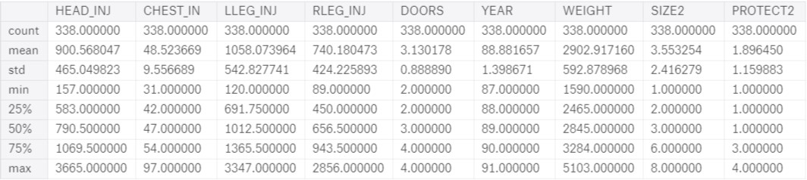
- Pairplot of significant variables
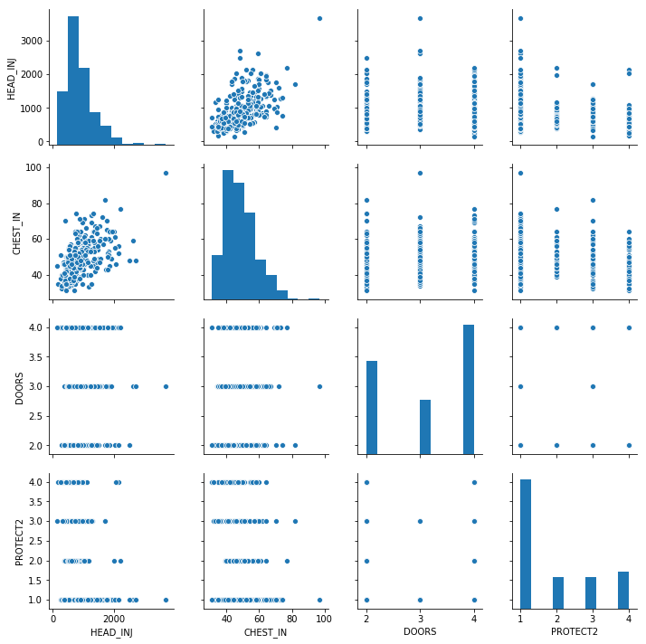

- OLS Regression Results after considering all variables as predictors
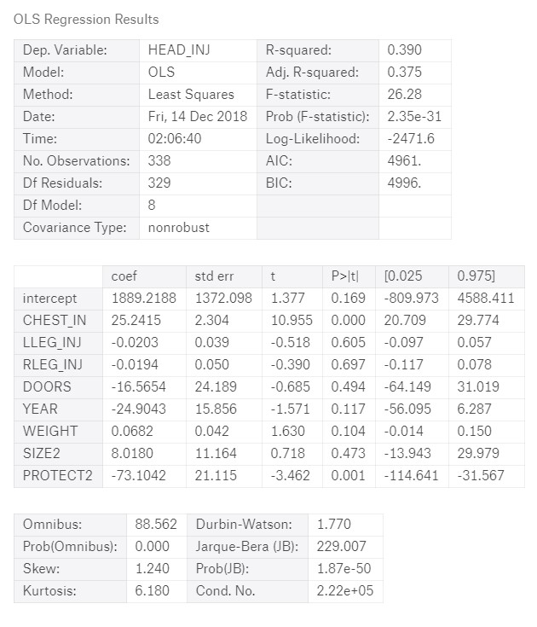
- Which company make had highest head injury count
- Which company make had lowest head injury count
- Which year car make had the highest head injury
- Which year car make had the lowest head injury

- Which types of protection have highest influence on head injury
- Which types of protection have least influence on head injury
- Significance of doors on head injury.
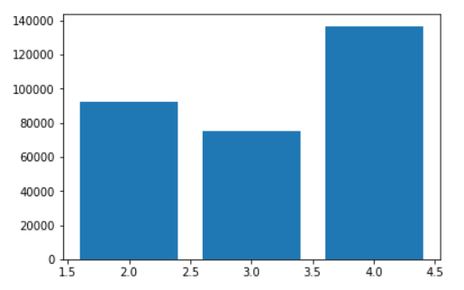
- Driver had more injury or passenger (line graph plot of driver and passenger based on various factors)
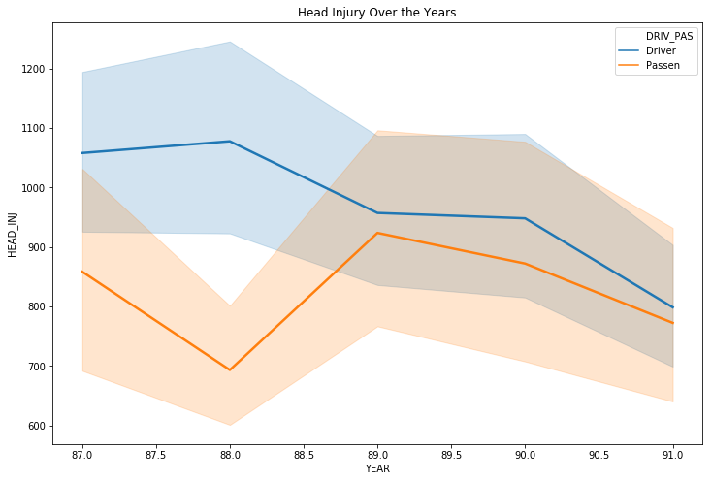
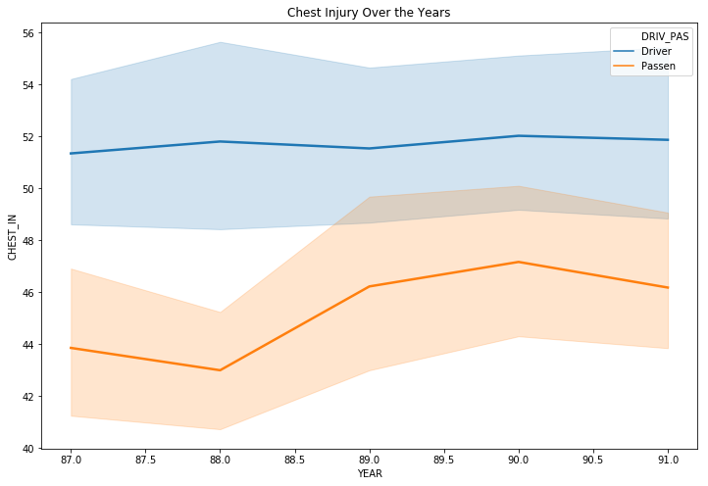
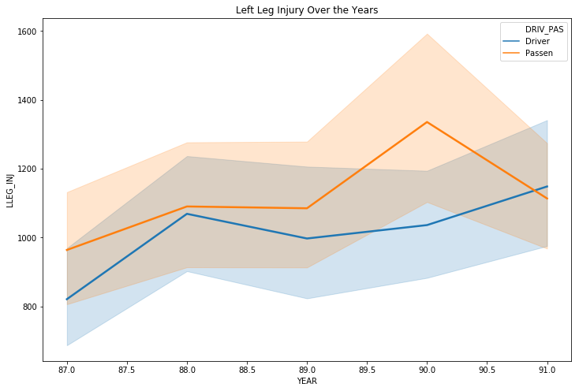
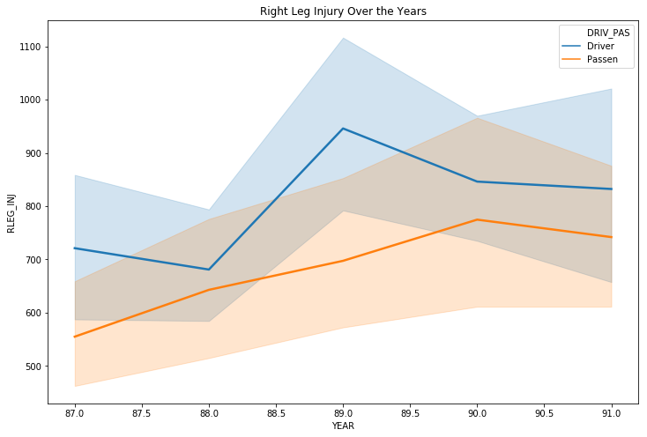
2.2 Product Perspective

This product Face Recognition Attendance Management System depends on the vast database of GLA University for the records of the students. The product will automate the various task associated with handling student details, surveillance inside the class and optimum performance thus helping the college authorities to ensure the smooth working of these processes.

2.3 Proposed Solution

To overcome the problems in existing attendance system we shall develop a Biometric based attendance system over simple attendance system. There are many solutions to automate the attendance management system like thumb based system, simple computerized attendance system but all these systems have limitations over work and security point of view. Our proposed system shall be a “Face Recognition Attendance System” which uses the basic idea of image processing which is used in many secure applications like banks, airports etc.

2.4 Proposed System Components
Following are the main components of the proposed system
- Student Registration
- Face Detection
- Face Recognition
- Feature Extraction
- Feature Classification
- Attendance management system
It will allow uploading, updating and deletion of the contents of the system.
Attendance management will handle:
- Automated Attendance marking
- Manual Attendance marking
- Attendance details of users.

2.5 Proposed System Outcome
- System will only allow authenticated user to login to the system and/or make changes to it.
- It will allow user to mark attendance of the students via face recognition technique.
- It will detect faces via webcam and then recognize the faces.
- After recognition it will mark the attendance of the recognized student and update the attendance record.
- The user will be able to print these record details afterward.

2.6 Contribution
Face recognition is the most natural biological features recognition technology according to the cognitive rule of human beings; its algorithm is ten times more complex than a fingerprint algorithm. Face recognition is featured by the following advantages compared to fingerprint:
->Accurate and Fast Identification
->High Usability and Security
->User friendly design

2.7 Specific Requirements

2.7.1 External Interface Requirements

2.7.1.1 User Interfaces

- GUI along with the meaningful frames and buttons.
- Reports are generated as per the requirement.

2.7.1.2 Hardware Interfaces

Hardware Requirement | Core 2 Duo 2nd generation
System Configuration | RAM – 2 GB DDR – 3
Operating System | Windows – 7/8/8.1/10
Other hardwares | D3D D8801 Home Security Camera (128 GB, 1 Channel)

2.7.1.3 Software Interfaces
Front End | Python
Back End | Python ,Open CV

2.7.1.4 Communication Interface

The machine will have to be the part of the Local Area Network to access central database.

2.8 Functional Requirements

The functional requirements that our product Face Recognition Attendance Management System will fulfill are given below.
- Taking and tracking student attendance by facial recognition in specific time.

- Sending the names of the absent student directly to the lecturer

- Permitting the lecturer to modify the student absent or late.

- Showing the names of who is absent or late in the screen to avoid errors.
Chapter 3

Software Design
3.1 Use Case
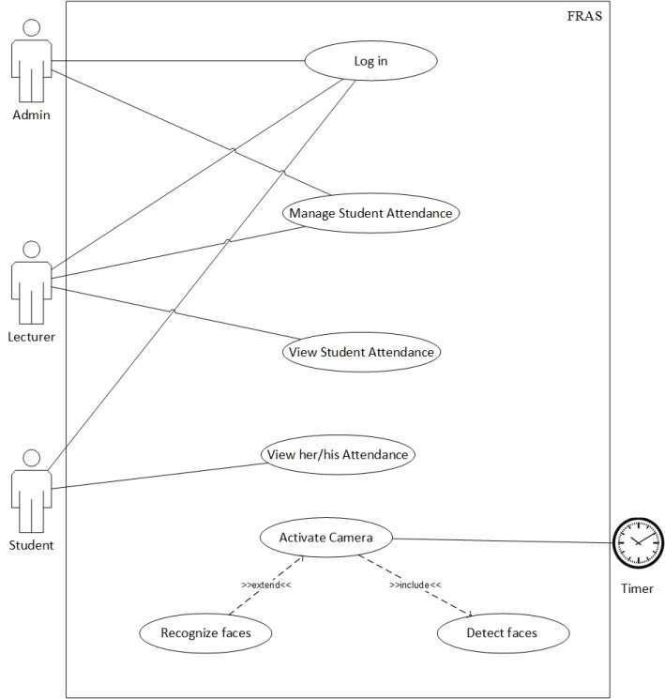

As shown in the use case diagram, the FRAS has actors named Admin, Lecturer and Student which are the main users of the system. Other actor, timer which turns camera on to record attendance by detecting and recognizing faces.

3.1.1 Use Case Description (Detailed Use Cases)

Log in
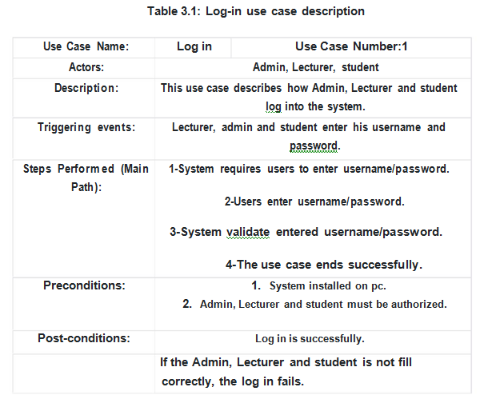

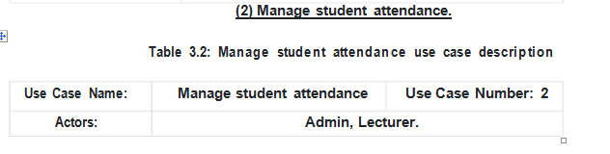

3.2 Data Flow Diagrams

Level 0
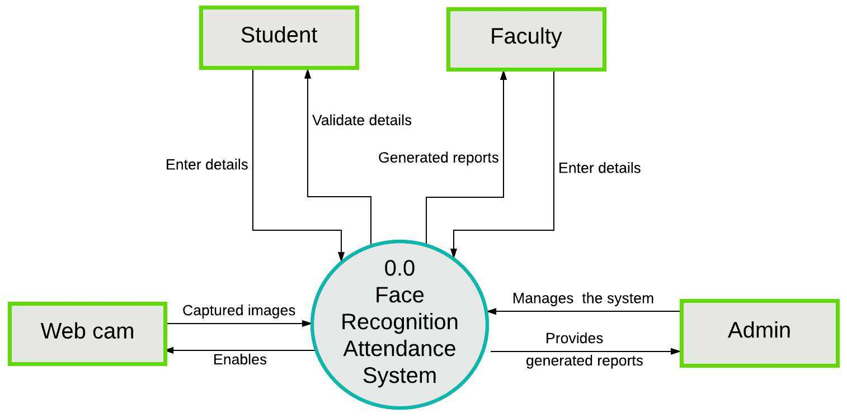

Level 1
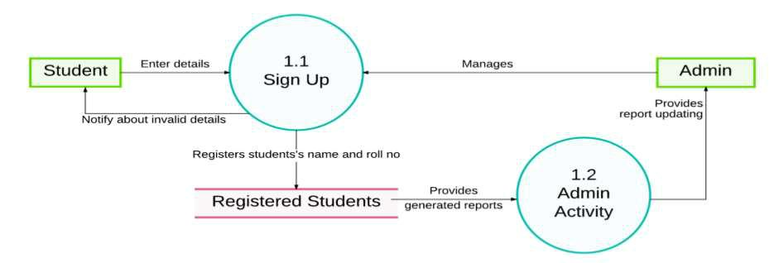

Student Registration Flow

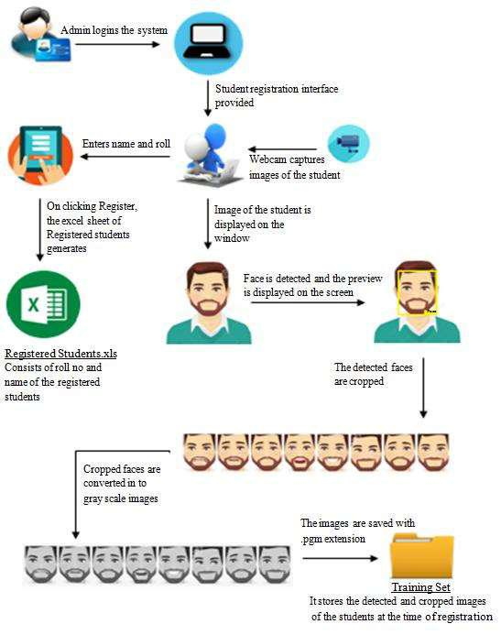

Figure 1: Student Registration Flow

Attendance Flow

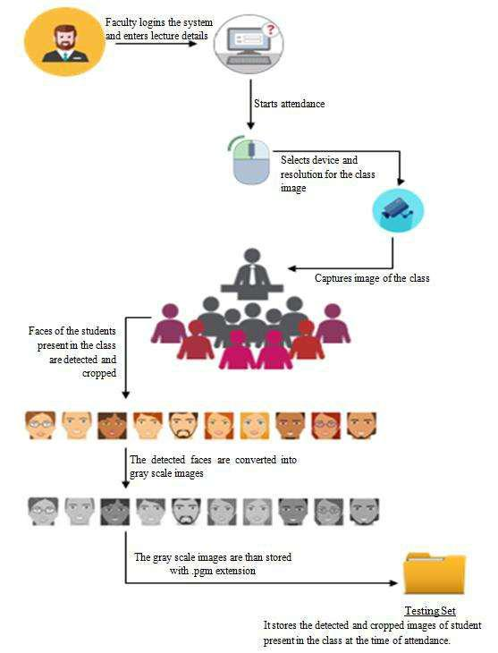

Figure 2 Taking Attendance Flow

Generating Attendance Flow
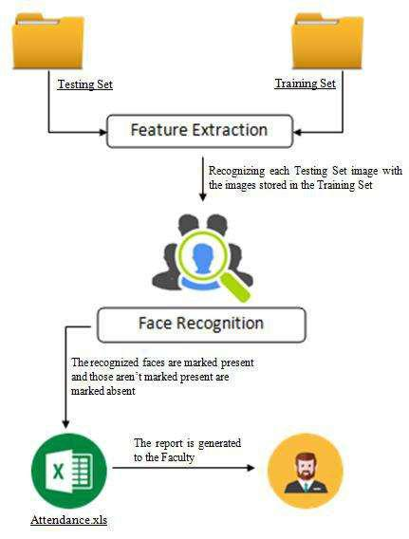

Figure 3 Generating Attendance Flow

3.3 Logical Database Requirements

Logical classification of data entities as well as their attributes.

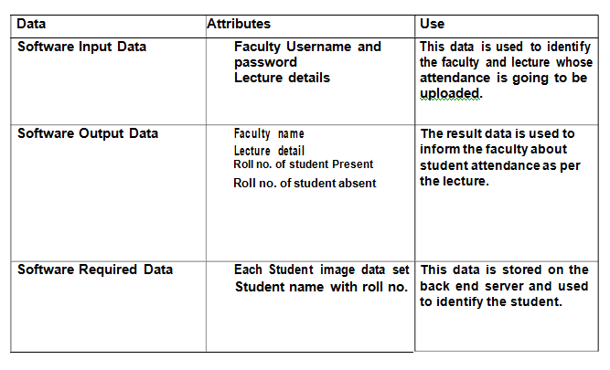

Chapter 4

Testing

4.1Introduction
System Development is a process of conceiving the specification specified in the designing stage into source code. Testing is the process of exercising software with the intent of finding errors and ultimately correcting them. The following testing techniques have been used to make this project free from errors.
4.2 Content Review
The whole content of the project has been reviewed thoroughly to uncover grammatical errors and ambiguous sentences.
4.3 Navigation Errors
Different users were allowed to navigate through the projects to uncover the navigation errors. The views of the user regarding the navigation flexibility and user friendliness were taken into account and implemented in the project.
4.4 White-Box Testing
White-Box Testing (also known as clear testing,structural testing and glass-box testing) tests internal structures or working of a program , as opposed to the functionality exposed to the end-users.
In white-box testing an internal logical path through the software are tested by providing test cases that exercise specific set of conditions and loops.
Using white box testing software development can derive test case that
- Guarantee that all independent paths within a module have been exercised at least once.
- Exercised internal data structure to ensure their validity.
- Exercise all loops at their boundaries and within their operational bound.

4.5 Black Box Testing

Black-box testing is a method of software testing that examines the functionality of an application without peering into its internal structures or working. This method of test can be applied to virtually every level of software testing: unit, integration, system & acceptance.

Chapter 5

Implementation and User-Interface
5.1 FRAS Screen:

This is the first GUI page of FRAS (Face Recognition Attendance System ) in which login option is shown by clicking on the login button we enter in the next page.

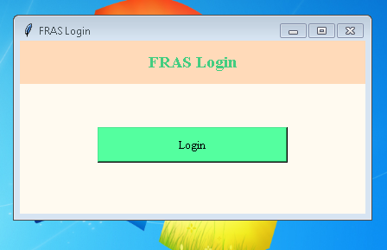

- This is the next page where the user after login have to enter the user name and password.
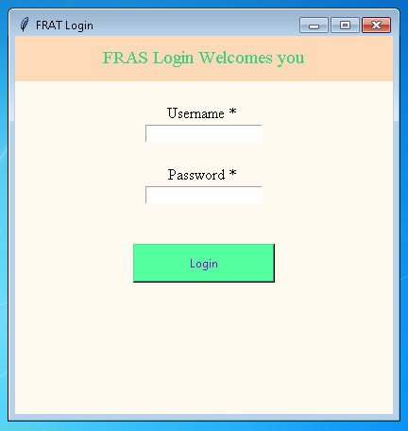
- After successful login Welcome screen of FRAS which shows course, branch, year ,section which is allotted to the lecturer. It also contains logout button to come back to the login page .

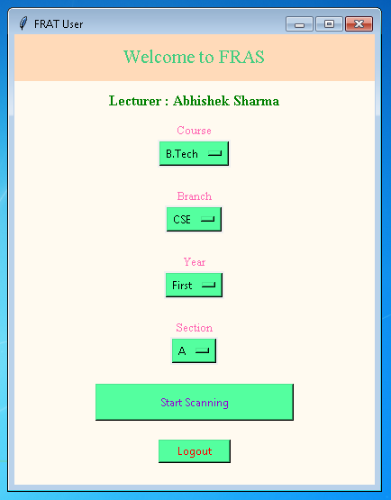
- This is how the scanning of face is seen .
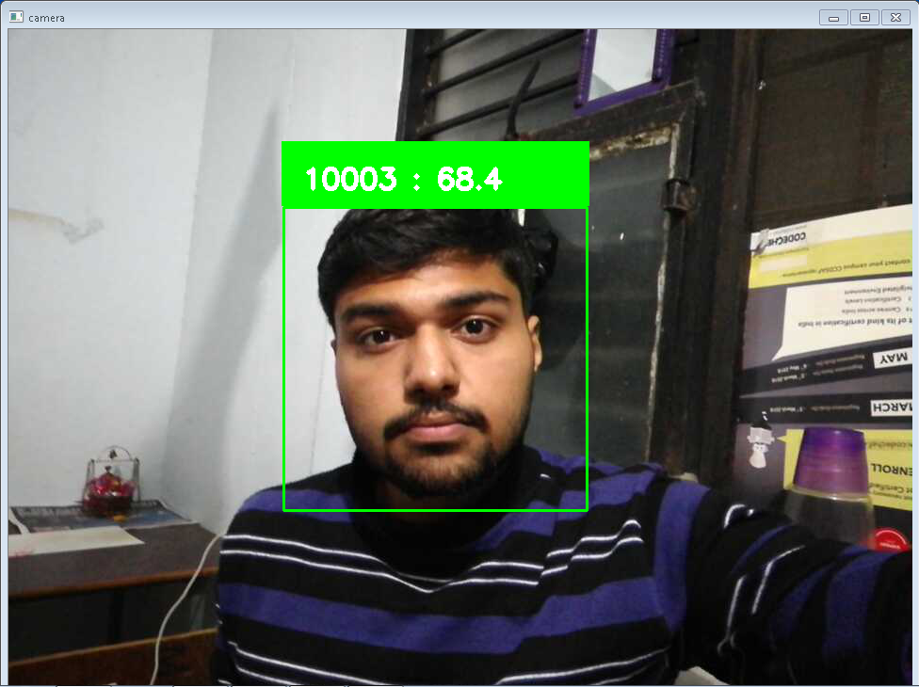

- After scanning the faces of all the present student Attendance sheet will be generated in which we can modify the attendance last time before saving the attendance.

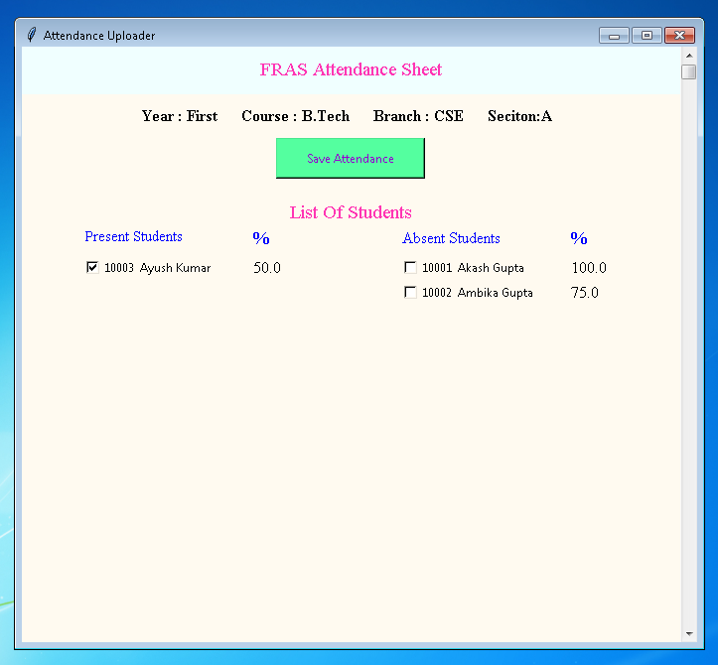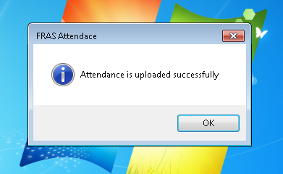

- Admin control panel page
Admin can create training model for face recognition algorithm from the dataset created by Generate dataset and admin can also provide a access to any faculty who want to take attendance by creating their user ID and password.
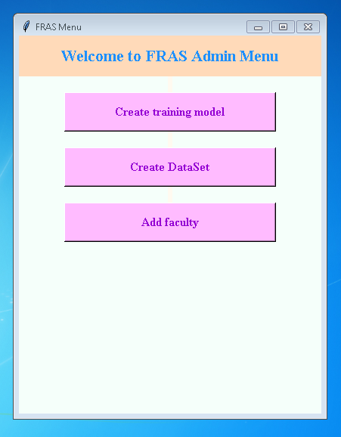

- FRAS Trainer page
This will get the dataset from specific location and generate training model using LBPH algorithm and save at specific location by the name trainer.yml.

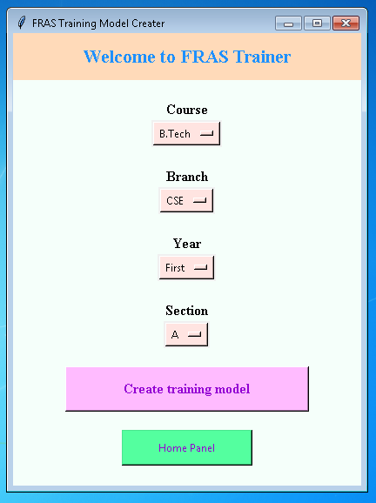
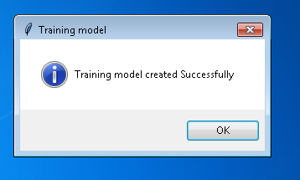
- FRAS Faculty Access page
This login page will create new user and delete old user

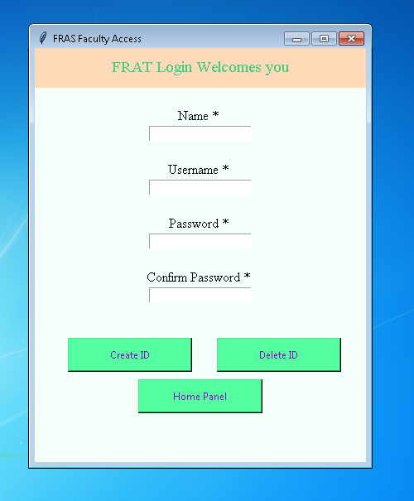

- FRAS Database

It consist of three table named as access, attendance and student
Access table store the name, user ID , password for Admin and faculty.
Student table store the name of students, ID of student,
Attendance table store the date and attendance of students.

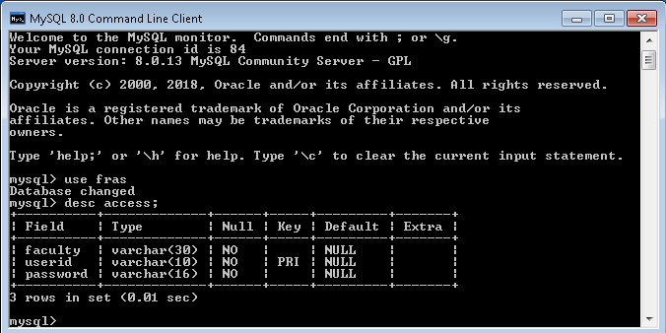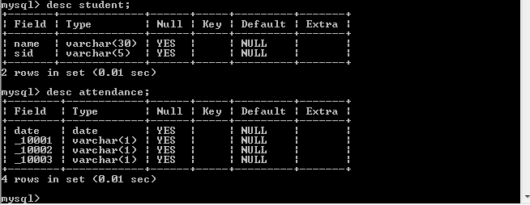

Chapter 6

References/Bibliography

Book:
Learning Open CV 3 Computer Vision with Python by Joe Minichino and Joseph Howse
Learing python by Mark Lutz, David Ascher

Websites:
- Diepen, G. (2017). Detecting and tracking a face with Python and OpenCV. Available at https://www.guidodiepen.nl/2017/02/detecting and-tracking-a-face-with-python-and-opencv/
- https://docs.opencv.org/3.0-beta/doc/py_tutorials/py_tutorials.html
- https://www.tutorialspoint.com/python/python_gui_programming.htm

Chapter 7

Appendices

Code:
#Login Page for Faculty
import mysql.connector
import tkinter as tk
from tkinter import messagebox
import faceRec
def faculty(screen):
screen.destroy()
screen = tk.Tk()
screen.configure(background='floral white')
screen.geometry("400x500")
screen.title("FRAT User")
year = tk.StringVar(screen)
year.set("First")
course = tk.StringVar(screen)
course.set("B.Tech")
branch = tk.StringVar(screen)
branch.set("CSE")
section = tk.StringVar(screen)
section.set("A")
tk.Label(text = "Welcome to FRAT", bg = "peach puff", width = "300", height = "2", font = ("Times", 16), fg = "SeaGreen3").pack()
tk.Label(text = "", bg = 'floral white').pack()
tk.Label(text = "Course", bg = 'floral white', font = ("Times", 10), fg = 'hot pink').pack()
m = tk.OptionMenu(screen, course, "B.Tech", "BBA", "BCA", "MBA", "Diploma")
m.configure(bg = 'SeaGreen1')
m.pack()
tk.Label(text = "", bg = 'floral white').pack()
tk.Label(text = "Branch", bg = 'floral white', font = ("Times", 10), fg = 'hot pink').pack()
a = tk.OptionMenu(screen, branch, "CSE", "ME", "EC", "EN","CE")
a.configure(bg = 'SeaGreen1')
a.pack()
tk.Label(text = "", bg = 'floral white').pack()
tk.Label(text = "Year", bg = 'floral white', font = ("Times", 10), fg = 'hot pink').pack()
w = tk.OptionMenu(screen, year, "First", "Second", "Third", "Fourth")
w.configure(bg = 'SeaGreen1')
w.pack()
tk.Label(text = "", bg = 'floral white').pack()
tk.Label(text = "Section", bg = 'floral white', font = ("Times", 10), fg = 'hot pink').pack()
b = tk.OptionMenu(screen, section, "A", "B", "C", "D", "E")
b.configure(bg = 'SeaGreen1')
b.pack()
tk.Label(text = "", bg = 'floral white').pack()
tk.Button(master=screen, text = "Start Scanning", fg = "dark violet", bg = "SeaGreen1", height = "2", width = "30", command = lambda : faceRec.face_rec(str(year.get()),str(course.get()),str(branch.get()),str(section.get()),screen.destroy())).pack()
tk.Label(text=" ",bg = 'floral white').pack()
tk.Button(master=screen, text = "Logout", fg = "red", bg = "SeaGreen1", height = "1", width = "10", command = lambda : mainScreen(screen.destroy())).pack()
def loginCheck(user,password,screen):
if user!="" and password!="":
mydb = mysql.connector.connect(host="localhost",user="root",passwd="root",database="fras")
mycursor= mydb.cursor()
query="select * from access where userid like '"+user+"' and password like '"+password+"';"
mycursor.execute(query)
result=mycursor.fetchall()
if result!=[]:
faculty(screen)
else:
messagebox.showerror("LOGIN","User ID and Password is Incorrect...")
login(screen)
else:
messagebox.showwarning("LOGIN","User ID and Password Required...")
login(screen)
def login(screen1):
screen1.destroy()
screen1=tk.Tk()
screen1.configure(background='floral white')
screen1.geometry("400x400")
screen1.title("FRAT Login")
tk.Label(screen1, text = "FRAT Login Welcomes you", bg = "peach puff", width = "300", height = "2", font = ("Times", 14), fg = "SeaGreen3").pack()
tk.Label(screen1, text = "", bg = 'floral white').pack()
tk.Label(screen1, text = "Username * ", bg = 'floral white', fg = 'black', font = ('Times',12)).pack()
user=tk.StringVar()
password= tk.StringVar()
tk.Entry(screen1, text = " ", textvariable=user).pack()
tk.Label(screen1, text = "", bg = 'floral white').pack()
tk.Label(screen1, text = "Password * ", bg = 'floral white', fg = 'black', font = ('Times',12)).pack()
tk.Entry(screen1, text = " ", textvariable=password,show="*").pack()
tk.Button(screen1, text = "Login", fg = "dark violet", bg = "SeaGreen1", height = "2", width = "20", command =lambda : loginCheck(str(user.get()),str(password.get()),screen1)).place(bordermode=tk.OUTSIDE, x=125, y=220)
def mainScreen(screen=None):
screen = tk.Tk()
screen.configure(background='floral white')
screen.geometry("400x200")
screen.title("FRAT Login")
tk.Label(text = "FRAT Login", bg = "peach puff", width = "300", height = "2", font = ("Times","14","bold"), fg = "SeaGreen3").pack()
tk.Label(text = "", bg = 'floral white').pack()
tk.Button(text = "Login", fg = "black", bg = "SeaGreen1",font=("Times","10") ,height = "2", width = "30", command = lambda: login(screen)).place(bordermode=tk.OUTSIDE, x=90, y=100)
screen.mainloop()
if __name__=="__main__":
mainScreen()

# Admin Control Page
import tkinter as tk
from tkinter import messagebox
import mysql.connector
import trainer
import generateDataSet
def createDataSet(screen=None):
generateDataSet.generate()
def createID(name,user,password,new_password,screen):
if user!="" and password!="" and name!="":
try:
if password == new_password:
db = mysql.connector.connect(host="localhost",user="root",passwd="root",database="fras")
mycursor= db.cursor()
query="insert into access values(%s,%s,%s)"
val=(name,user,password)
mycursor.execute(query,val)
db.commit()
if mycursor.rowcount==1:
messagebox.showinfo("Insert","Faculty added successfully...")
add_faculty(screen)
else:
messagebox.showerror("LOGIN","User ID and Password is Incorrect...")
add_faculty(screen)
else:
messagebox("warning","Password mismatch...")
return
except mysql.connector.Error as error:
messagebox.showerror("Insert Error",error)
add_faculty(screen)
else:
messagebox.showwarning("LOGIN","User ID and Password Required...")
add_faculty(screen)
def deleteID(name,user,password,new_password,screen):
if user!="" and password!="" and name!="":
try:
if password == new_password:
db = mysql.connector.connect(host="localhost",user="root",passwd="root",database="fras")
mycursor= db.cursor()
query="delete from access where userid like '"+user+"' and password like '"+password+"';"
mycursor.execute(query)
db.commit()
if mycursor.rowcount==1:
messagebox.showinfo("Insert","Faculty deleted successfully...")
add_faculty(screen)
else:
messagebox.showerror("LOGIN","User ID and Password is Incorrect...")
add_faculty(screen)
else:
messagebox("warning","Password mismatch...")
return
except mysql.connector.Error as error:
messagebox.showerror("Delete Error",error)
add_faculty(screen)
else:
messagebox.showwarning("LOGIN","User ID and Password Required...")
add_faculty(screen)
def add_faculty(screen):
screen.destroy()
screen = tk.Tk()
screen.configure(background="mint cream")
screen.geometry("400x500")
screen.title("FRAS Faculty Access")
tk.Label(screen, text = "FRAT Login Welcomes you", bg = "peach puff", width = "300", height = "2", font = ("Times", 14), fg = "SeaGreen3").pack()
name= tk.StringVar()
tk.Label(screen, text = "", bg = 'floral white').pack()
tk.Label(screen, text = "Name * ", bg = 'floral white', fg = 'black', font = ('Times',12)).pack()
tk.Entry(screen, text = " ", textvariable=name).pack()
tk.Label(screen, text = "", bg = 'floral white').pack()
tk.Label(screen, text = "Username * ", bg = 'floral white', fg = 'black', font = ('Times',12)).pack()
user= tk.StringVar()
password= tk.StringVar()
new_password= tk.StringVar()
tk.Entry(screen, text = " ", textvariable=user).pack()
tk.Label(screen, text = " ", bg = 'floral white').pack()
tk.Label(screen, text = "Password * ", bg = 'floral white', fg = 'black', font = ('Times',12)).pack()
tk.Entry(screen, text = " ", textvariable=password,show="*").pack()
tk.Label(screen, text = " ", bg = 'floral white').pack()
tk.Label(screen, text = "Confirm Password * ", bg = 'floral white', fg = 'black', font = ('Times',12)).pack()
tk.Entry(screen, text = " ", textvariable=new_password,show="*").pack()
tk.Button(screen, text = "Create ID", fg = "dark violet", bg = "SeaGreen1", height = "2", width = "20", command =lambda : createID(str(name.get()),str(user.get()),str(password.get()),str(new_password.get()),screen)).place(bordermode=tk.OUTSIDE, x=40, y=350)
tk.Button(screen, text = "Delete ID", fg = "dark violet", bg = "SeaGreen1", height = "2", width = "20", command =lambda : deleteID(str(name.get()),str(user.get()),str(password.get()),str(new_password.get()),screen)).place(bordermode=tk.OUTSIDE, x=220, y=350)
tk.Button(screen, text = "Home Panel", fg = "dark violet", bg = "SeaGreen1", height = "2", width = "20", command = lambda: panel(screen.destroy())).place(bordermode=tk.OUTSIDE, x=125, y=400)
def trainerPage(screen):
screen.destroy()
screen = tk.Tk()
screen.configure(background='mint cream')
screen.geometry("400x500")
screen.title("FRAT Training Model Creater")
year = tk.StringVar(screen)
year.set("First")
course = tk.StringVar(screen)
course.set("B.Tech")
branch = tk.StringVar(screen)
branch.set("CSE")
section = tk.StringVar(screen)
section.set("A")
tk.Label(text = "Welcome to FRAT Trainer", bg = "peach puff", width = "300", height = "2", font = ("Times", 16,"bold"), fg = "dodgerblue").pack()
tk.Label(text = "", bg = 'floral white').pack()
tk.Label(text = "Course", bg = 'floral white', font = ("Times", "12", "bold"), fg = 'black').pack()
m = tk.OptionMenu(screen, course, "B.Tech", "BBA", "BCA", "MBA", "Diploma")
m.configure(bg = 'misty rose')
m.pack()
tk.Label(text = "", bg = 'floral white').pack()
tk.Label(text = "Branch", bg = 'floral white', font = ("Times", "12", "bold"), fg = 'black').pack()
a = tk.OptionMenu(screen, branch, "CSE", "ME", "EC", "EN","CE")
a.configure(bg = 'misty rose')
a.pack()
tk.Label(text = "", bg = 'floral white').pack()
tk.Label(text = "Year", bg = 'floral white', font = ("Times", "12", "bold"), fg = 'black').pack()
w = tk.OptionMenu(screen, year, "First", "Second", "Third", "Fourth")
w.configure(bg = 'misty rose')
w.pack()
tk.Label(text = "", bg = 'floral white').pack()
tk.Label(text = "Section", bg = 'floral white', font = ("Times", "12", "bold"), fg = 'black').pack()
b = tk.OptionMenu(screen, section, "A", "B", "C", "D", "E")
b.configure(bg = 'misty rose')
b.pack()
tk.Label(text = "", bg = 'floral white').pack()
tk.Button(text = "Create training model", fg = "dark violet", font=("Times","12","bold"), bg = "plum1", height = "2", width = "30", command = lambda : trainer.train(str(year.get()),str(course.get()),str(branch.get()),str(section.get()))).pack()
tk.Label(text="",bg='floral white').pack()
tk.Button(screen, text = "Home Panel", fg = "dark violet", bg = "SeaGreen1", height = "2", width = "20", command = lambda: panel(screen.destroy())).pack()
def panel(screen=None):
screen = tk.Tk()
screen.configure(background='mint cream')
screen.geometry("400x500")
screen.title("FRAS Menu")
tk.Label(text = "Welcome to FRAS Admin Menu", bg = "peach puff", width = "300", height = "2", font = ("Times", 16,"bold"), fg = "dodgerblue").pack()
tk.Label(text = "", bg = 'floral white').pack()
tk.Button(text = "Create training model", fg = "dark violet", font=("Times","12","bold"), bg = "plum1", height = "2", width = "30", command = lambda : trainerPage(screen)).pack()
tk.Label(text="",bg="floral white").pack()
tk.Button(text = "Create DataSet", fg = "dark violet", font=("Times","12","bold"), bg = "plum1", height = "2", width = "30", command = lambda :createDataSet(screen.destroy)).pack()
tk.Label(text="",bg="floral white").pack()
tk.Button(text = "Add faculty", fg = "dark violet", font=("Times","12","bold"), bg = "plum1", height = "2", width = "30", command = lambda : add_faculty(screen)).pack()
screen.mainloop()
if __name__=="__main__":
panel()

# Face Recognition and Attendance marking
import os
import cv2
import urllib
import tkinter as tk
from tkinter import messagebox
import numpy as np
import mysql.connector
import datetime
url='http://192.168.201.2:8080/shot.jpg'
def save(newvar,screen=None):
mydb = mysql.connector.connect(host="localhost",user="root",passwd="root",database="fras")
mycursor= mydb.cursor()
tod=datetime.date.today()
query= "insert into attendance (date) values('"+str(tod)+"');"
mycursor.execute(query)
mydb.commit()
for x,y in newvar.items():
if str(y.get())=='1':
query="update attendance set _"+str(x)+" ='P' where date like '"+str(tod)+"';"
else:
query="update attendance set _"+str(x)+" ='A' where date like '"+str(tod)+"';"
mycursor.execute(query)
mydb.commit()
mycursor.close()
messagebox.showinfo("FRAS Attendace","Attendance is uploaded successfully")
def assurePath(path):
dir=os.path.dirname(path)
if not os.path.exists(path):
os.makedirs(dir)
def attendanceSheet(present):
mydb = mysql.connector.connect(host="localhost",user="root",passwd="root",database="fras")
mycursor= mydb.cursor()
global screen
screen = tk.Tk()
screen.configure(background = 'floral white')
screen.geometry("1000x800")
screen.title("List Of Students")
tk.Label(text = "FRAS Attendance Sheet", bg = "azure", width = "300", height = "2", font = ("Times", 14), fg = "maroon1").pack()
tk.Label(text = "", bg = 'floral white').pack()
tk.Label(text = "List Of Students", bg = "floral white", font = ("Times", 14), fg = "maroon1").pack()
tk.Label(screen, text = "Present Students", fg = 'blue', bg = 'floral white', font = ('Times',11)).place(x = 160, y = 120)
tk.Label(screen, text = "Attendance", fg = 'blue', bg = 'floral white', font = ('Times',12)).place(x = 330, y = 120)
tk.Label(screen, text = "Absent Students", fg = 'blue', bg = 'floral white', font = ('Times',12)).place(x = 580, y = 120)
tk.Label(screen, text = "Attendance", fg = 'blue', bg = 'floral white', font = ('Times',12)).place(x = 750, y = 120)
var=dict()
name=dict()
for x in present:
var[x]=tk.IntVar(value=1)
query="select name from student where sid like '"+str(x)+"';"
mycursor.execute(query)
result=mycursor.fetchone()
for n in result:
name[x]=n
inc=30
for x in present:
tk.Checkbutton(screen, text=str(x)+" "+str(name[x]), variable=var[x], bg = 'floral white').place(x = 160, y = 120+inc)
inc+=25
absent=set()
name=dict()
var2 = dict()
query="select name , sid from student;"
mycursor.execute(query)
if (mycursor.rowcount==1):
result=mycursor.fetchone()
else:
result=mycursor.fetchall()
for x,y in result:
if int(y) not in present:
var2[y]=tk.IntVar(value=0)
absent.add(y)
name[y]=x
inc =30
for x in absent:
tk.Checkbutton(screen, text=str(x) + " "+str(name[x]), variable=var2[x], bg = 'floral white').place(x = 580, y = 120+inc)
inc+=25
tk.Label(text="",bg='floral white').pack()
tk.Button(screen, text = "Save Attendance", fg = "dark violet", bg = "SeaGreen1", height = "2", width = "20", command = lambda: save({**var, **var2} ,screen.destroy())).pack()
screen.mainloop()
def face_rec(year,course,branch,section,screen=None):
present=set()
model=cv2.face.LBPHFaceRecognizer_create()
path="C:\\Users\\Abhishek\\trainer\\"+course+"\\"+branch+"\\"+year+"\\"+section+"\\"
assurePath(path)
try:
model.read(path+"trainer.yml")
except Exception as e:
messagebox.showerror("FRAS Error",e)
font =cv2.FONT_HERSHEY_SIMPLEX
face_cascade =cv2.CascadeClassifier('C:\\Users\\Abhishek\\Anaconda3\\pkgs\\libopencv-3.4.1-h875b8b8_3\\Library\\etc\\haarcascades\\haarcascade_frontalface_default.xml')
try:
while(True):
imgResponse = urllib.request.urlopen(url)
# Numpy to convert into a array
imgNp = np.array(bytearray(imgResponse.read()),dtype=np.uint8)
# Decode the array to OpenCV usable format
img = cv2.imdecode(imgNp,-1)
gray=cv2.cvtColor(img,cv2.COLOR_BGR2GRAY)
faces=face_cascade.detectMultiScale(gray,1.3,5)
for(x,y,w,h) in faces:
cv2.rectangle(img,(x-20,y-20),(x+w+20,y+w+20),(0,255,0),2)
roi=cv2.resize(gray[y:y+h,x:x+w],(200,200),interpolation=cv2.INTER_LINEAR)
id,confidence = model.predict(roi)
present.add(id)
cv2.rectangle(img,(x-22,y-90),(x+w+22,y-22),(0,255,0),-1)
cv2.putText(img,str(id)+" : "+str(confidence),(x,y-40),font,1,(255,255,255),3)
cv2.imshow("camera",img)
if cv2.waitKey(10)& 0xff ==ord("q"):
break
cv2.destroyAllWindows()
attendanceSheet(present)
except Exception as e:
messagebox.showerror("FRAS Error",e)

# DataSet generater
import cv2
import numpy as np
import urllib
url='http://192.168.201.2:8080/shot.jpg'
def generate():
Id=0
eye_cascade=cv2.CascadeClassifier('C:\\Users\\Abhishek\\Anaconda3\\pkgs\\libopencv-3.4.1-h875b8b8_3\\Library\\etc\\haarcascades\\haarcascade_eye.xml')
face_cascade =cv2.CascadeClassifier('C:\\Users\\Abhishek\\Anaconda3\\pkgs\\libopencv-3.4.1-h875b8b8_3\\Library\\etc\\haarcascades\\haarcascade_frontalface_default.xml')
print("Starting Creating Face Recognition dataset" )
while(True):
imgResponse = urllib.request.urlopen(url)
# Numpy to convert into a array
imgNp = np.array(bytearray(imgResponse.read()),dtype=np.uint8)
# Decode the array to OpenCV usable format
img = cv2.imdecode(imgNp,-1)
gray=cv2.cvtColor(img,cv2.COLOR_BGR2GRAY)
faces=face_cascade.detectMultiScale(gray,1.3,5)
for x,y,w,h in faces:
cv2.rectangle(img,(x,y),(x+w,y+h),(255,0,0),2)
f=cv2.resize(gray[y:y+h,x:x+w],(200,200))
Id=Id+1
cv2.imwrite('C:\\Users\\Abhishek\\Local data\\'+str(Id)+'.jpg',f)
roi_gray=gray[y:y+h,x:x+w]
eyes=eye_cascade.detectMultiScale(roi_gray,1.1,3)
for ex,ey,ew,eh in eyes:
cv2.rectangle(img[y:y+h,x:x+w],(ex,ey),(ex+ew,ey+eh),(0,255,0),2)
cv2.imshow("camera",img)
if cv2.waitKey(int(1000/12)) & 0xff==ord("q"):
break
cv2.destroyAllWindows()
print("Dataset is created successfully and saved at C:\\Users\\Abhishek\\local data")
if __name__=="__main__":
generate()

# Training Model for Face recognition
import cv2
import os
from tkinter import messagebox
from PIL import Image
import numpy as np
def assurePath(path):
dir=os.path.dirname(path)
if not os.path.exists(dir):
os.makedirs(dir)
def getImageAndLabel(path):
face_cascade =cv2.CascadeClassifier('C:\\Users\\Abhishek\\Anaconda3\\pkgs\\libopencv-3.4.1-h875b8b8_3\\Library\\etc\\haarcascades\\haarcascade_frontalface_default.xml')
eye_cascade=cv2.CascadeClassifier('C:\\Users\\Abhishek\\Anaconda3\\pkgs\\libopencv-3.4.1-h875b8b8_3\\Library\\etc\\haarcascades\\haarcascade_eye.xml')
assurePath(path)
imagePaths = [os.path.join(path,f) for f in os.listdir(path)]
faceSamples=[]
ids=[]
for imagePath in imagePaths:
PIL_img=Image.open(imagePath).convert('L')
img=np.array(PIL_img,"uint8")
id=int(os.path.split(imagePath)[-1].split(".")[0])
faces=face_cascade.detectMultiScale(img)
for (x,y,w,h) in faces:
faceSamples.append(cv2.resize(img[y:y+h,x:x+w],(200,200)))
ids.append(id)
return faceSamples, ids
def train(year,course,branch,section):
try:
recognizer=cv2.face.LBPHFaceRecognizer_create()
path="C:\\Users\\Abhishek\\faceDataSet\\"+course+"\\"+branch+"\\"+year+"\\"+section+"\\"
faces,ids=getImageAndLabel(path)
recognizer.train(faces,np.array(ids))
assurePath("C:\\Users\\Abhishek\\trainer\\"+course+"\\"+branch+"\\"+year+"\\"+section+"\\")
recognizer.save("C:\\Users\\Abhishek\\trainer\\"+course+"\\"+branch+"\\"+year+"\\"+section+"\\trainer.yml")
messagebox.showinfo("Training model","Training model created Successfully")
except Exception as e:
messagebox.showerror("Training model",e)

